My offer
A full day writing workshop : £250
A half day writing workshop: £170
A poetry performance: from £90
A full length poetry performance with musicians: from £290
A week's direction or production: £750
Mentorship per hour: £48.
For the writing of libretti and scripts, and for the direction of projects, I adhere to ITC (Independent Theatre Council) rates, appropriate to the spoken or sung length of the work.
In addition to the above fees, I charge mileage at 25p, or second class rail fare. I am DRB checked and fully insured. Most of my workshops, projects and commissions are negotiated carefully with the client. I can offer bespoke workshops or choose from a popular range of 'ready-mades' including:
Character
Building a character – for script, prose and poetry.
What brings a character alive? I pass on tips and strategies from my work as a librettist, scriptwriter and poet to make your characters jump off the page. Find out about contradictory characteristics, an old green overcoat and a character compass you can follow to the end of the plot.
Other peoples' lives
Poetry as 'life writing'
My poems tell the stories of many different people, from a Cotswold farmer to a Kurdish refugee, from Laurie Lee to Joseph Shabalala of Ladysmith Black Mambazo. Through reading, reflection and writing exercises, we explore how poetry can be used as a form of biography to dig deeply into the lives of those we know or admire.
Seasons of fruitfulness
Writing the seasons in poetry
How can we celebrate seasonal change with verve and panache, escaping the beautiful clichés of lazy hazy days, crisp snow underfoot and gambolling lambs? I share inventive approaches derived from seasonal poetry in Japanese and other cultures, as well as from my imaginative work with children.
Poetry and music performances available for booking

Of feathered friends
An entertaining performance about birds with poet Adam Strickson, and folk musicians Steve Harrison and Annie Dearman.
This programme was put together in summer 2014 after Adam had been making bird sculptures and writing bird poems inspired by Dewsbury Country Park as part of the Yorkshire Festival, welcoming the Grand Départ of the Tour de France.
Fly with the Spen heron and whirl with a teacup ride of reed buntings. Listen to beautiful ballads and twittering tunes.
Steve & Annie are in demand all over England, from Whitby to Kent. Their CD with Vic Gammon, Black Crow/White Crow, was released by the English Folk Dance & Song Society to glowing reviews.
4 free full colour poem-posters are available at all readings for audience members.
Find out more about Adam's residency at Dewsbury Country Park here:
http://www.adamstrickson-artist.com/#!plant-life-cycle/c1dqj
Find more out about the musicians here:
http://www.dearmanharrison.co.uk/
Duration: 1 hour 50 minutes, including a 15 minute interval
Cost: £290
Technical requirements: none, but the programme can include a short, illustrated talk on Adam's sculptures if a data projector and projector screen are available.

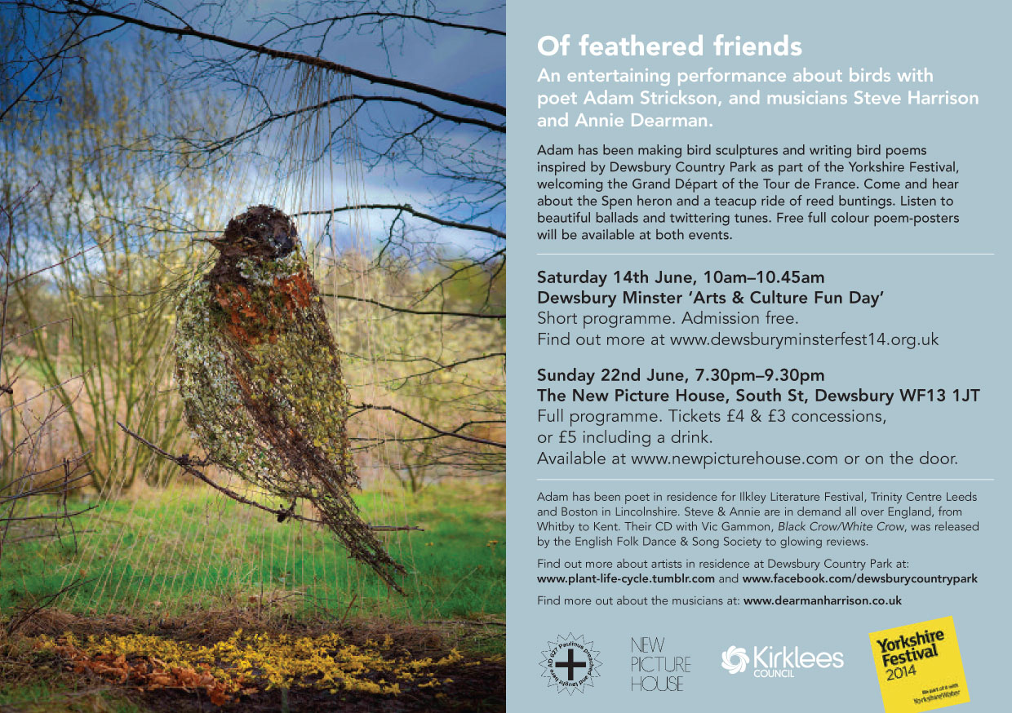

Air on Brontë Moor
Poetry, music and film about the Brontës and their landscape with jazz saxophonist David Wilson and film-maker Simon Warner.
This collaboration brings together literary, visual and musical responses to the Brontës and their landscape. Adam Strickson reads verse by the Brontës, Sylvia Plath, Ted Hughes and Charlotte Mew alongside his own poems. Simon Warner projects video and photographs shot recently on Haworth Moor, and delves into his archive of 35 years. Saxophonist David Wilson plays his own compositions that are directly inspired by visits to Haworth and the moors, and that also draw on research into music the Brontës played and enjoyed.

http://www.simonwarner.co.uk/

http://davidwilsonmusic.co.uk/

https://www.facebook.com/aironbrontemoor
https://itunes.apple.com/gb/album/air-on-bronte-moor/id596063244
Some comments on the premiere at Bradford Cathedral in December 2013. The programme was also performed for the Bronte Society AGM in Haworth on 13 June 2014, and is available for bookings throughout 2015 and 2016.

"I wanted to mention what an excellent performance it was on Wednesday. I really thought it was a superb, immersive experience and very well performed by everyone. To me it really summed up the time of year and the beauty and bleakness of Haworth and surrounding moor area."

"I have really enjoyed Air on Brontë Moor performance. It's been a while since I was in the presence of such a spiritual, contemplative, idiosyncratic, l'art pour l'art event that offers a welcome escape. Yours and your colleagues' impressions of the moors felt deep and ethereal at the same time."

Duration: 1 hour 20 minutes
Technical requirements: we can bring all amplification and film equipment including a suitable screen but need blackout.
Cost: £600

